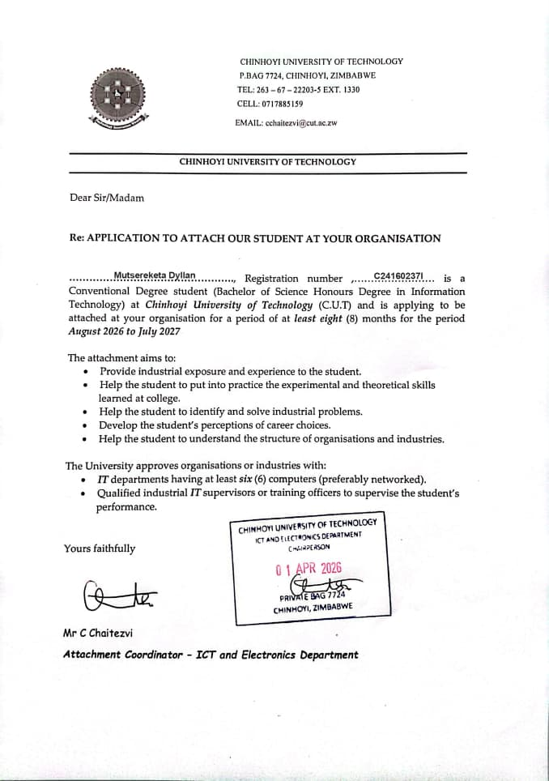

 |  |  | Dyllan mutsereketa  Profile  Motivated Information Technology student currently in Level 3.1, with strong programming and problem solving skills. I have experience in Data Science, Networking, Java, C#, C, SQL, PHP, and web technologies, and have completed several academic projects and other ongoing real life projects.  I am passionate about software development, data science and eager to contribute to innovative and technically challenging projects in a professional environment. Access my portfolio at www.portfolio.hollandsck.site to view all the projects I have worked on  Education  Chinhoyi University of Technology, Chinhoyi  Aug 2024-March 2028  - Bachelor of Science Honours Degree in Information Technology  - Current level 2.2  Princeton Institute ZW, Mutare  Jan 2022-November 2023  - GCE Advanced Level  - Subjects (Computer Science, Economics, Business Studies)  Holy Ghost College, Marange  Jan 2018-November 2021  - GCE Ordinary Level  - Passed 11 Subjects including (Maths, English and Science)  Projects i have worked on  - CeSHHAR Zimbabwe MASCOT/ mHealth Tool  - Hollandsck Intelligent Property Auction & Verification System (HPAVS)  - ZAFM Church Management System  - ServiceBridgeAI(USAII Global Hackathon)  - Oconnect Marketplace(on going project)
Personal Information
 | 1479 Flamelily New Msasa Park
 | ₊₂₆₃₇₈ ₀₃₆ ₈₇₁₅
 | dyllanmutsereketa@gmail.com
   | www.linkedin.com/in/dyllan-mutsereketa-519855390  www.portfolio.hollandsck.site

23/06/2004
Skills
- Technical skills
Networking and Infrastructure, Web development, Data Science, Operating Systems, Software Development, Database Systems, prompt engineering, UI designer
- Programming languages
C, JAVA, JavaScript, C#, DART)
- Web Development
PHP, MySQL, Xampp, HTML, CSS, Figma
- Data Science (Jupyter Notebook, PowerBi, Python data science libraries)

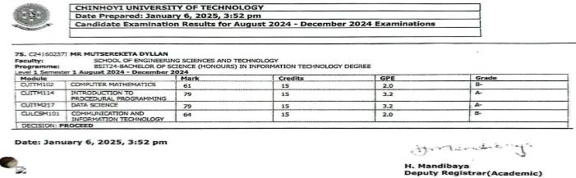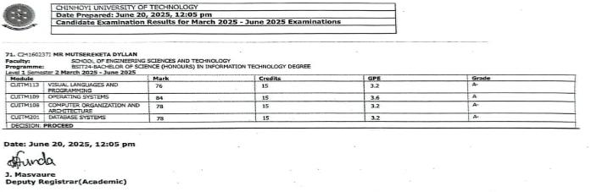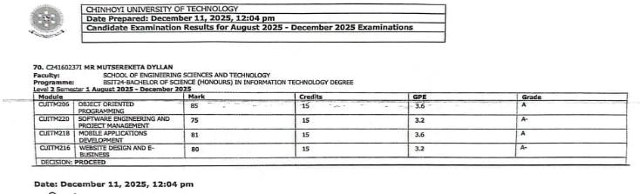
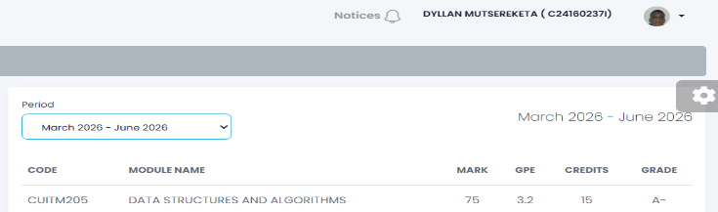

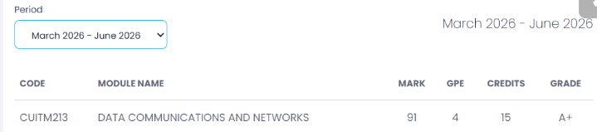

CareNest mHealth Tool | CeSHHAR Zimbabwe mHealth Hackathon 2026
Over two intense days at the Rainbow Towers Hotel Harare, we competed against top talent to develop digital solutions aimed at addressing critical gaps in HIV and reproductive health access for tertiary students in Zimbabwe.
team project | HavenTech

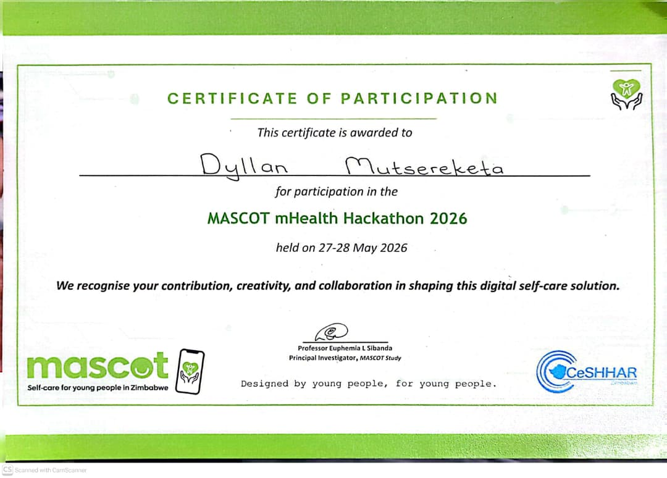

USAII Global AI Hackathon 2026 – Finalist
United States Artificial Intelligence Institute (USAII), June 2026
- Selected as a Finalist in the Undergraduate category.
- Co-developed ServiceBridge AI – Benefits Navigator, an AI-powered platform that helps users identify eligible government benefits, prepare application documents, and access trusted guidance.
- Demonstrated practical skills in AI application development, software engineering, problem-solving, teamwork, and responsible AI design.
- View it here: https://servicebridge-ai.vercel.app/
