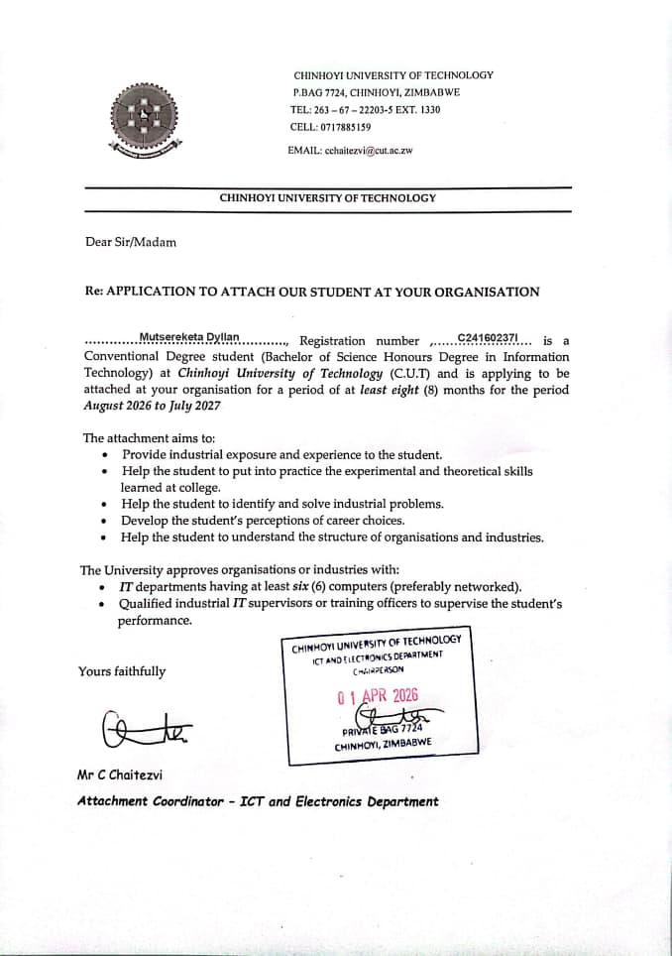

 |  |  | Dyllan mutsereketa  Profile  Motivated Information Technology student currently in Level 2.2, with strong programming and problem solving skills. I have experience in Data Science, Networking, Java, C#, C, SQL, PHP, and web technologies, and have completed several academic projects and other ongoing real life projects.  I am passionate about software development, data science and eager to contribute to innovative and technically challenging projects in a professional environment. Access my portfolio at www.portfolio.hollandsck.site  Education  Chinhoyi University of Technology, Chinhoyi  Aug 2024-March 2028  - Bachelor of Science Honours Degree in Information Technology  - Current level 2.2  - Some Level 2.2 results pending…..  Princeton Institute ZW, Mutare  Jan 2022-November 2023  - GCE Advanced Level  - Subjects (Computer Science, Economics, Business Studies)  Holy Ghost College, Marange  Jan 2018-November 2021  - GCE Ordinary Level  - Passed (Maths, English and Science)
Personal Information
 | Mutare, Dangamvura  4838 Area 3
 | ₊₂₆₃₇₈ ₀₃₆ ₈₇₁₅
 | dyllanmutsereketa@gmail.com
   | www.linkedin.com/in/dyllan-mutsereketa-519855390  www.portfolio.hollandsck.site

23/06/2004
Skills
- Technical skills Programming, Networking, Web development, Data Science, Operating Systems, Software Development, Database Systems
- Programming languages (C, JAVA, C#, DART)
- Web Development (PHP, MySQL, Xampp, HTML, CSS)
- Data Science (Jupyter Notebook, PowerBi, Python data science libraries)

